VENANGO TECHNOLOGY CENTER
JOINT COMMITTEE
1 Vo-Tech Drive
Oil City, Pennsylvania 16301

MINUTES

November 1, 2021

The regular meeting of the Venango Technology Center Joint Committee was held this evening in the Conference Room of the Venango Technology Center, 1 Vo-Tech Drive, Oil City, PA 16301. Mr. Carson called the meeting to order at three minutes past seven o’clock (7:03) p.m.

Mr. Carson asked the members to pause for a moment of silence.

Mr. Carson asked the members to stand for the pledge of allegiance.

Roll Call: Present: Robert Blauser, Andy Boland (zoom), Shari Neely, Todd Carson, James Come,
Troy Johnston (phone)

Absent: Mark Marterella, James Disque, Don Judy, Jeff Thomas

Also Present: Mr. Mario Fontanazza

Mr. Carson stated the Joint Committee members had received copies of the Minutes of the October 4, 2021 meeting in the mail. He asked if there were any additions, corrections or deletions.

Mrs. Neely, seconded by Mr. Blauser, moved to approve the Minutes of the October 4, 2021 meeting as submitted.

Roll Call: Ayes: Robert Blauser, Andy Boland, Shari Neely, Todd Carson, James Come,
Troy Johnston

Nayes: None, motion carried.

The Treasurer and Secretary’s Report as of 11/1/21 was submitted for information.

Mr. Blauser, seconded by Mrs. Neely, moved to accept the Treasurer and Secretary’s Report as of 11/1/21 as submitted.

The motion was unanimously approved.

A list of bills from in the amount of $425,350.77 was presented for approval.

Mrs. Neely, seconded by Mr. Blauser, moved to approve the list of bills as presented.

Roll Call: Ayes: Robert Blauser, Andy Boland, Shari Neely, Todd Carson, James Come,
Troy Johnston

Nayes: None, motion carried.

Under Communications, Mr. Fontanazza discussed the Professional Advisory Committee. He discussed the strengths and challenges of the Comprehensive Plan that is to be approved tonight. He also discussed the Calendar of Events for the month of October and the Monthly Enrollment Report as of 11/1/21 were submitted.

Mr. Carson requested approval of the action items as presented. Item 8. a) i.- v. in one motion.

Mr. Blauser, seconded by Mrs. Neely, moved to approve action items 8. a) i.- v. as follows:

- Approve additions to the Occupational Advisory Committees.
- Approve James Woodworth for the Maintenance Supervisor position and the corresponding Act 93 agreement. The annual salary is prorated based on the number of days worked.
- Approve Sue Clarke as candidate for the instructional aide position. The annual salary is $12,500.00 prorated based on the number of days worked.
- Approve Comprehensive Plan as presented.
- Approve Kelton Burkhart to attend Skill Boss training in Columbus Indiana on December 20 – 23, 2021 at a cost not to exceed $2,700.00. Funding – Local

Roll Call: Ayes: Robert Blauser, Andy Boland, Shari Neely, Todd Carson, James Come,
Troy Johnston

Nayes: None, motion carried.

Mr. Fontanazza reviewed his Issues/Activities for October 2021.

Mr. Carson asked if there was any old business.

None was noted.

Mr. Carson asked if there was any new business.

None was noted.

Upon motion by Mr. Blauser, seconded by Mrs. Neely, the meeting adjourned at seven eighteen (7:18) p.m.

Recorded by
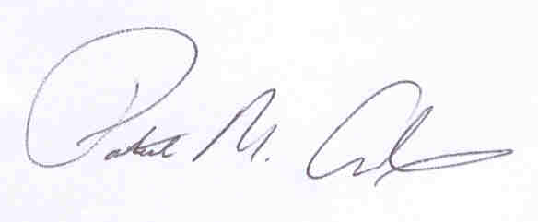
Patrick M. Adams
Secretary, Joint Committee

